INSTALLATION MANUAL

Table of Contents

Applicable Version………………..…....……………………………….……………………….1

Installation....………………………….……….……………………………………………………1

Configuring Wordline………………..……………………………………………………………3

Applicable versions

Applications | Versions
PHP | 5.6 to 7.4.x
Opencart | 2.2.x

Installation & Upgrade

Please follow the given steps to install and run the Wordline Payment Gateway module

1. Copy all files/folders recursively(admin & catalog) to opencart installation directory
2. Go to Extensions->Payments and install the Wordline gateway extension.

3. Then under Navigations go to System->Users->User Groups
4. Edit Top Administrator,
Under Access Permission select custom/reconciliation and custom/verification.
Under Modify Permission select custom/reconciliation and custom/verification

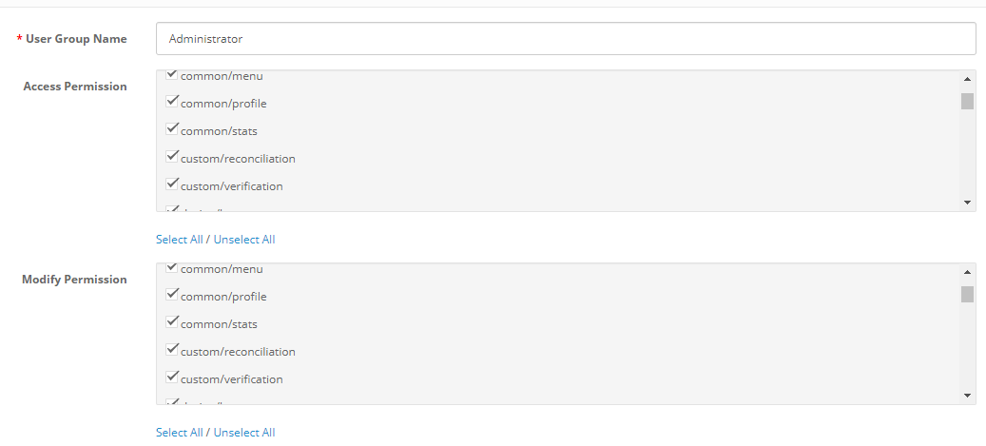
5. Click on save

Update Plugin

- Under Navigation Go to Extensions->Extensions select type as payments and Uninstall Wordline

2. After the successful uninstallation, install the updated Wordline package as mentioned above.

Configuring Wordline

- Go-to go to Extension->Extensions choose type as payments
- Scroll down. You will see Wordline, Edit it
- Configure it as below:

Column Name | Description
Status | “Enable” to enable and use, else “Disable” to disable Wordline
Merchant Code | Enter Merchant Code
Salt | Enter Salt.
Payment Type | For Test mode Select ‘Test’ and for Live mode select ‘Live’
Merchant Scheme Code | Enter Scheme Code

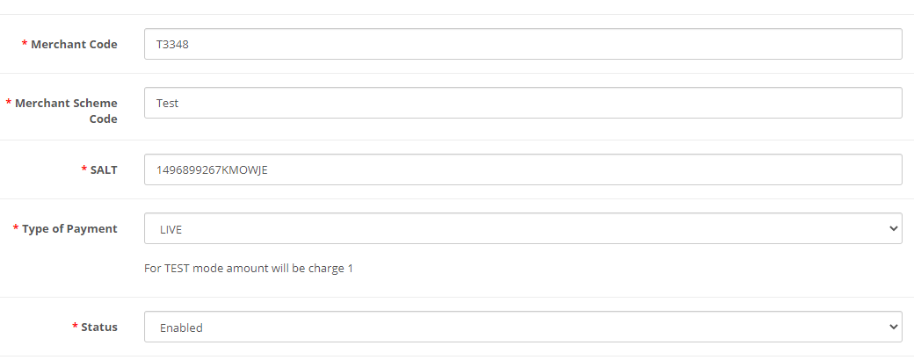
- Now click on “Save Changes” on top- right corner.
- Wordline Payment Gateway is now configured & ready to use.

Advanced Configuration

There are also some advanced configuration options you may consider as shown below:
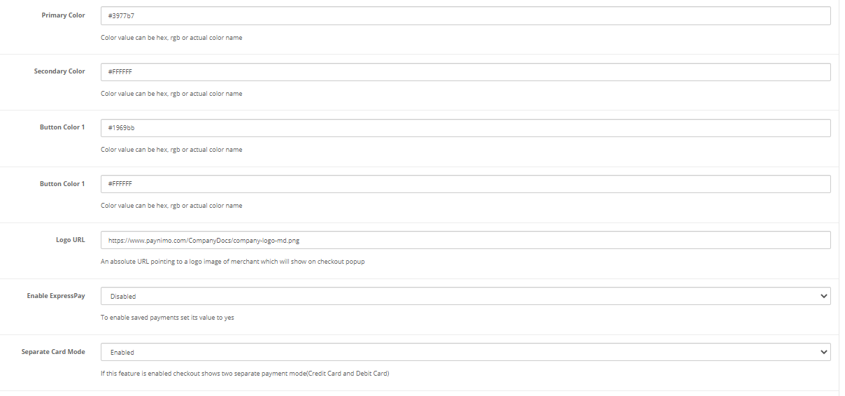

Features List

Dual verification of response
We are validating responses with a hash value and call again Payment Gateway for dual verification from the payment gateway before updating to the order status.

Reconciliation

Merchants can update the pending status of the order automatically if the payments are successful. This page can be found under Extensions- > Payment-> Configure Wordline Gateway->Reconciliation

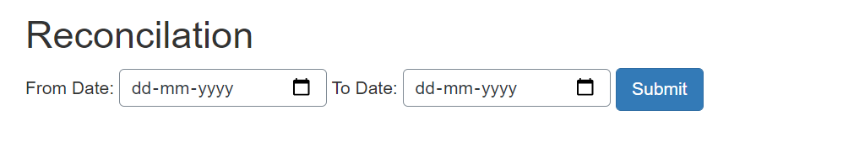

Logs request and response

Daily new file creates for the logs request and response from the server for future reference.

S2S Verification
If we do not receive any response from the payment gateway then after 30 mins, we will get a response from the server and based on the response it will update order status.
To configure S2S URL, contact prod team.

S2S url format : hostname/index.php?route=payment/wordline/s2sverification&msg=
S2S url example: http://example.com/index.php?route=payment/wordline/s2sverification&msg=

MCG
It supports the multi currency like USD, GBP, SGD and a lot more.

Offline Verification

Merchants can verify the status of their payment by using the Payment Verification page. The payment verification page can be found under Extensions- >Payment-> Configure Wordline Gateway->Offline Verification

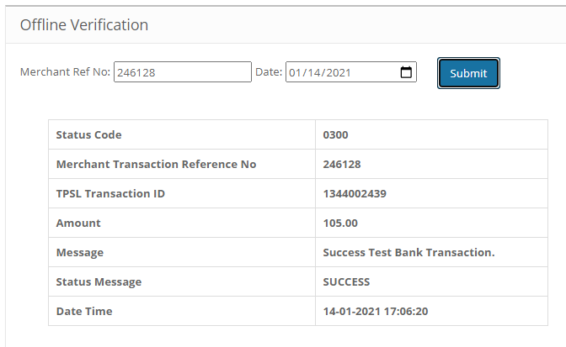

Refund
Merchants should be able to process the refund online for the order whose payment has been done via Wordline.

To refund an order click on view for particular order you want to refund and click on Wordline under Order History Section.

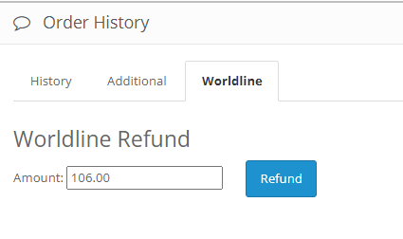

Embed Payment Gateway

After enabling this setting, payment gateway displays like embedded on the page instead of pop-up so user experience would be good.

Documentation link
https://www.tecprocesssolution.com/proto/p2m/client/salt-based-documentation.htm#online

